

***Table of Contents***

|  |
| --- |
| 1. Executive Summary |
| 1. Introduction |
| 1. Target Audiences and Focus Areas |
| 1. *Phishing Campaign Manager Dataset* |
| 1. Objectives |
| 1. Advantages |
| 1. Assumptions |
| 1. Business Rules |
| 1. BI Dashboard Analysis |
| 1. Findings and Insights |
| 1. Recommendations |
| 1. *HR Manager Dataset* |
| 1. Objectives |
| 1. Advantages |
| 1. Assumptions |
| 1. Business Rules |
| 1. BI Dashboard Analysis |
| 1. Findings and Insights |
| 1. Recommendations |
| 1. *IT/Security Team Dataset* |
| 1. Objectives |
| 1. Advantages |
| 1. Assumptions |
| 1. Business Rules |
| 1. BI Dashboard Analysis |
| 1. Findings and Insights |
| 1. Recommendations |
| 1. Conclusion |
| 1. References |
| 1. Appendices |

***Strengthening Cyber Defences: Phishing Campaign Insights at Secure Bank***

Secure Bank, one of Australia’s leading financial institutions, is committed to strengthening its cybersecurity infrastructure through targeted phishing simulations. These simulations are designed to test employee awareness, Training effectiveness and employee response towards it, and identify vulnerabilities across the organization. To make this process efficient, three Business Intelligence (BI) dashboards are created**. I have taken a new artificial dataset to simulate realistic phishing simulation outcomes**. These dashboards provide valuable insights for Phishing Campaign Managers, HR Managers, and the IT and Security Team to take informed action.

***Target Audience and Their Focus Areas***

***Phishing Campaign Managers***

* **Focus:** Track phishing campaign performance and analyse objectives.
* **Key Metrics:** Open Rates, Click-Through Rates, Response Rates, Campaign Objectives, Employee Responses.
* **Objective:** Identify vulnerabilities and optimize future campaigns.

***HR Managers***

* **Focus:** Assess employee awareness and responses during simulations.
* **Key Metrics:** Security Awareness Scores, Phishing Email Responses, Training Completion Rates (2021–2025).
* **Objective:** Measure training impact and improve awareness in high-risk areas.

***IT and Security Team***

* **Focus:** Enhance security and prevent data breaches.
* **Key Metrics:** Risk Level Analysis, Action Logs, Data Compromised, Attack Delivery Mechanisms.
* **Objective:** Strengthen defences, respond swiftly to threats, and protect sensitive data

***Phishing Campaign Manager Dataset***

* ***Departmental Risk Identification:***  
  Consolidate Open Rates, Click-Through Rates, and Response Rates by department to identify vulnerable areas quickly.
* ***Campaign Performance Tracking:***  
  Analyse past simulation data to measure campaign effectiveness and spot weaknesses.
* ***Phishing Tactic Evaluation:***  
  Compare phishing tactics like Credential Harvesting and Link-Based Phishing to understand employee vulnerabilities.
* ***Strategic Campaign Enhancement:***  
  Use historical data to optimize future campaigns, targeting weak spots for better security.

***Advantages***

* *Spot High-Risk Departments:*

Easily identify which departments are most at risk based on Open Rates and Click-Through Rates, helping to target awareness training and simulations more effectively.

* *Evaluate Phishing Tactics Effectively:*

Understand which phishing methods work best, making it simpler to plan stronger and more impactful campaigns.

* *Track Campaign Success Over Time:*

Monitor how phishing simulations perform year after year, clearly seeing improvements and areas that need more focus.

* *Improve Future Campaigns:*

Learn from past simulations to make future campaigns smarter and more focused, boosting awareness and reducing vulnerabilities.

***Assumptions***

*Campaign Objectives Influence Engagement:*  
Different phishing campaign objectives like **Raise Awareness**, **Prevent Fraud**, and **Verify Identity** impact employee engagement rates differently, as seen in Open and Click-Through Rates.

*Branch Locations Affect Response Patterns:*  
Employee responses may vary across **Brisbane** and **Melbourne** due to differences in training focus and awareness levels.

*Yearly Trends Reflect Awareness Growth:*  
Year-over-year analysis of Open and Click-Through Rates suggests that regular simulations help improve employee awareness and response accuracy over time.

|  |  |  |  |
| --- | --- | --- | --- |
| **Attribute** | **Data Type** | **Description** | **Business Rule** |
| **Campaign ID** | Character | Unique identifier for each phishing campaign. | Primary Key Must be a combination of a letter followed by three digits (e.g., C123). Cannot be NULL. |
| **Campaign Objective** | Character | Describes the objective of the phishing campaign (e.g., Raise Awareness, Prevent Fraud). | Must be one of the predefined campaign objectives. Cannot be NULL. |
| **Attachments Open Rate (%)** | Numeric | Percentage of emails opened by employees. | Must be a positive decimal or integer value, between 0 and 100. Cannot be NULL. |
| **Click-Through Rate (%)** | Numeric | Percentage of clicked phishing emails. | Must be a positive decimal or integer value, between 0 and 100. Cannot be NULL. |
| **Response Rate (%)** | Numeric | Percentage of phishing emails that received a response. | Must be a positive decimal or integer value, between 0 and 100. Cannot be NULL. |
| Overall Employee Engagement | Character | Employee Engagement in Campaign. | Must have only two values ; Positive or Negative |
| **Branch Location** | Character | Locations where the phishing campaigns were executed (e.g., Brisbane, Melbourne). | Must be a valid branch location of Secure Bank. Cannot be NULL. |

***Phishing Campaign Analysis Dashboard***

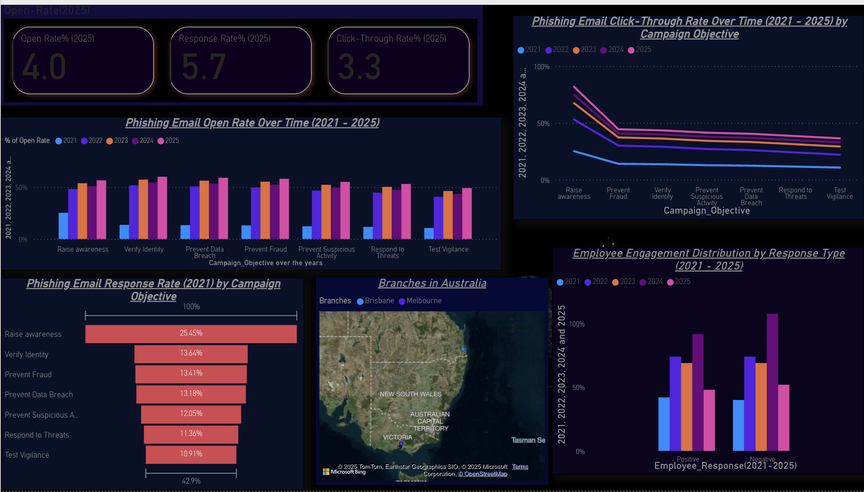

Figure :Phishing Campaign Manager Dashboard

SecureBank's Phishing Campaign Analysis Dashboard offers a clear representation of phishing simulation performance by 8000 employees spanning from 2021 to 2025. It illustrates the Open Rate and Click-Through Rate Trends, demonstrating employee interaction with phishing emails. Additionally, it encompasses the Response Rate categorized by Campaign Objective, emphasizing which campaign goals (such as Raise Awareness and Prevent Fraud) experience the greatest engagement, thereby highlighting out areas of weakness. The dashboard includes a Geographical Analysis in Brisbane and Melbourne to identify high-risk branches. Moreover, it illustrates the distribution of employee engagement by recording both positive and negative interactions. This analysis helps in targeting future campaigns based on negative responses and pinpointing areas that require greater awareness.

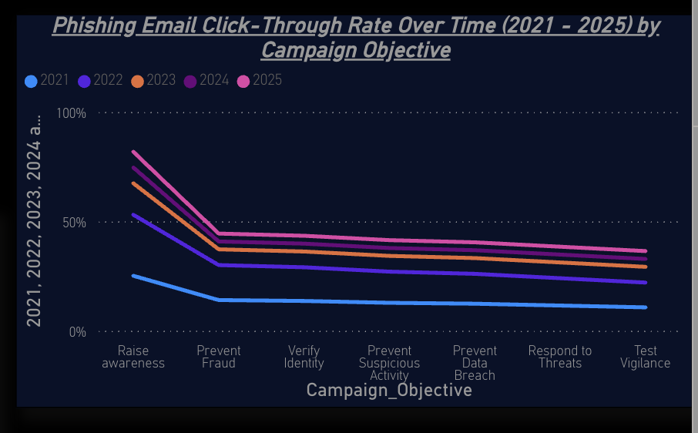

Figure 2: Phishing Email Clicked by Different Campaign Objective

***Selection of Visualization***

A Line Chart was selected for this analysis due to its strong effectiveness in depicting trends across time periods. It clearly illustrates the changes in the Click-Through Rate (CTR) for various campaign objectives from 2021-2025, assisting the monitoring of increases or decreases across years

***Insights***

In 2021, the Click-Through Rate (CTR) for "Raise Awareness" began at approximately 25%, and it saw remarkable growth of 82% by 2025. “Prevent Fraud” came next, increasing from 13% in 2021 to 45% in 2025.  
  
In contrast, “Prevent Fraud”, “Prevent Suspicious Activity”, “Prevent Data breach”, “Respond to Threads”, "Test Vigilance" remained at a low between 10% and 35% over the years, indicating that it may require greater focus and awareness.

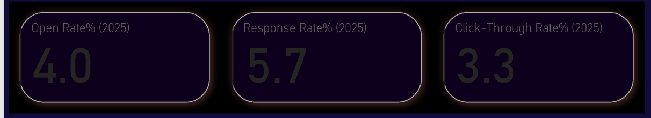

Figure 3:Open rate vs Response Rate vs Click through rate in 2025

***Selection of Visualization***

KPI Cards are ideal for displaying key figures simply and clearly. It enables stakeholders to grasp essential statistics quickly, without having to navigate through complex charts.

***Insights***

Open Rate for all Phishing campaign Objective Emails is 4.0% in 2025, indicating that employees are improving their ability to identify phishing emails and are not opening them as frequently.  
  
Response Rate is 5.7% in 2025 suggesting that although awareness is increasing, there is potential for better engagement in simulations.  
  
Click-Through Rate is 3.3% in 2025 indicating gradual decrease over the years suggests that employees are exercising greater caution and are less inclined to click on phishing links.

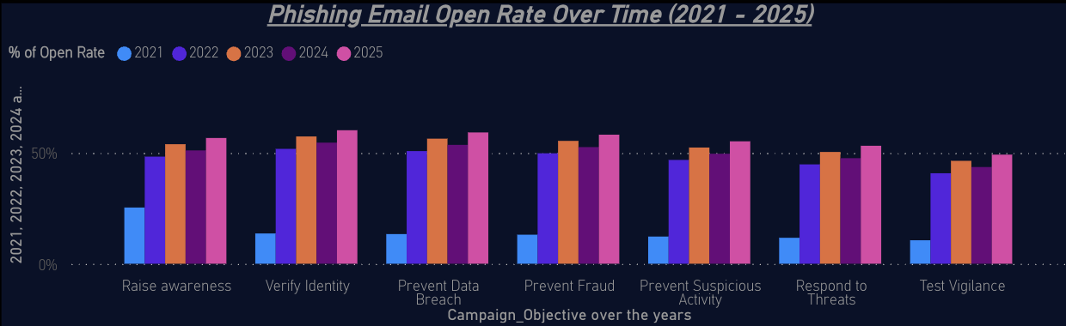

Figure 4:Phishing Email Open rate(2021-2025)

***Selection of Visualization***

Clustered Column chart effectively display the open rates for various campaign objectives over time. It facilitates an easy year-by-year comparison, bringing attention to trends and change

***Insights***

The "Raise Awareness" campaign achieved the highest open rate in 2021, whereas "Test Vigilance" fell behind. This suggests a greater awareness of general threats but a lack of engagement focused on vigilance.  
  
The period from 2021 to 2022 saw a notable increase of 30% across all campaigns, indicating enhanced employee awareness. Nonetheless, the period from 2022 to 2023 experienced only slight growth, indicating a possible plateau in engagement.  
  
The 1% decline in 2024 suggested a need for updated training, but 2025 experienced a minor recovery with a 2% increase, driven by "Verify Identity" as the leading campaign for open rates. This change indicates an increasing focus on phishing attempts that focused on identity.

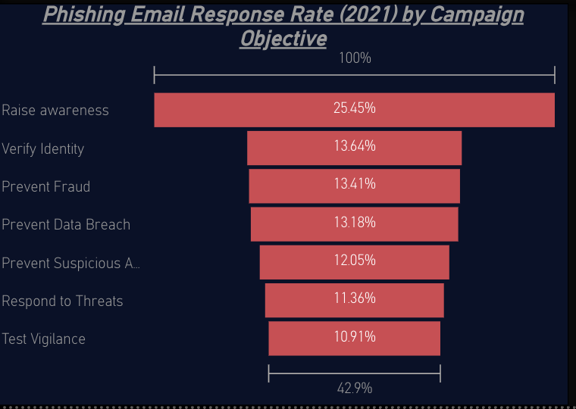

Figure 5:Phishing Email Response rate

***Selection of Visualization***

Funnel charts serve as excellent tools for visualizing stepwise data, facilitating the easy detection of drop-off points in employee engagement across various phishing campaign objectives.

***Insights***

* **Raise Awareness** is the most effective, with a **25.45%** response rate, indicating strong engagement.
* **Verify Identity** and **Prevent Fraud** follow at **13.64%** and **13.41%**, showing moderate awareness.
* The lowest response rates are seen in **Test Vigilance** (**10.91%**) and **Respond to Threats** (**11.36%**), signalling a need for better training.

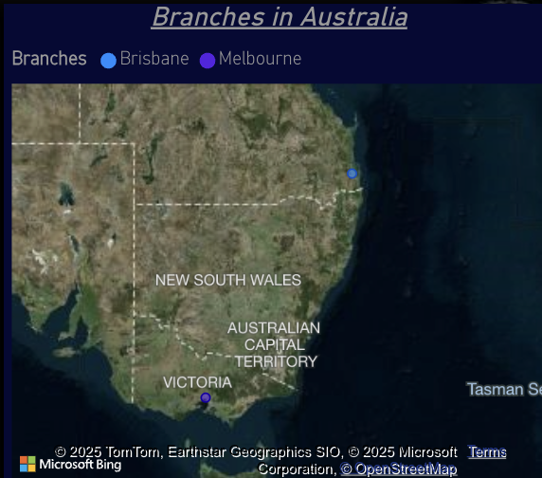

Figure 6:Branches in Australia

***Selection of Visualization***

Map visualizations are ideal for spotting regional vulnerabilities quickly.

***Insights***

Phishing engagement hotspots have been identified in Brisbane and Melbourne, indicating that these areas may be more vulnerable to phishing attempts.

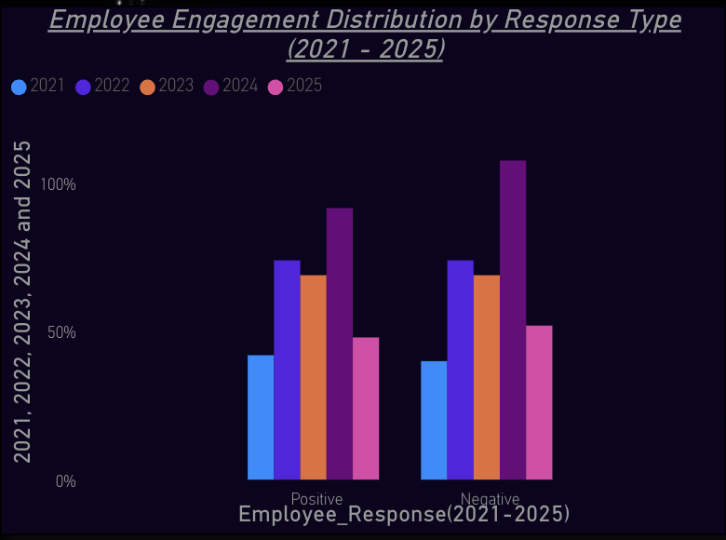

Figure 7:Employee Engagement(Negative vs Positive)

***Selection of Visualization***

Bar charts effectively display positive and negative response distributions across multiple years, making it easy to compare shifts over time.

***Insights***

2021 to 2023 recorded balanced response rates for both types, indicating consistent employee interaction.  
  
2024 demonstrates the greatest number of both positive and negative responses, with the latter reaching a peak of approximately 90%.  
  
The year 2025 saw a drop in both positive and negative feedback, indicating better awareness.

***Recommendation***

* ***Improve Low-Performing Campaign Objectives:***  
  Campaigns like "Test Vigilance," "Prevent Suspicious Activity," and "Respond to Threats" consistently show low engagement. More interactive phishing simulations can boost awareness and response rates **(Beuran, 2025; Abbas, 2024).**
* ***Targeted Training for High-Risk Locations:***  
  The map analysis highlighted Brisbane and Melbourne as phishing hotspots. Localized training and awareness sessions can address these vulnerabilities **(Kalevrosoglou, 2024).**
* ***Dynamic Phishing Simulations:***  
  The consistent increase in click-through rates for "Raise Awareness" and "Prevent Fraud" shows familiarity. Regularly rotating phishing templates can improve detection **rates (Asad Abbas, 2024).**
* ***Quarterly Awareness Refreshers:***  
  Slow increase in open rates in 2025 suggests training fatigue. Implementing quarterly training refreshers with updated phishing tactics can maintain engagement and awareness **(Lee Heesuk, 2022).**

***HR MANAGER DATASET***

***Objectives***

***Employee Awareness Assessment*:**  
Monitor phishing email responses like "Opened but Ignored" and "Details Filled" for 6,097 employees to identify awareness gaps.

***Training Completion and Impact Analysis*:**  
Track training completion rates from 2021 to 2025 to measure employee progress and program effectiveness.

***Identification of High Risks:***  
Analyse "Phishing Link Clicked" and "Phishing Email Opened" rates to identify high-risk teams and individuals.

***Security Awareness Improvement:***  
Compare Security Awareness Scores annually to evaluate the impact of HR-led training programs.

***Advantages***

*Spot High Risk Employees:*

Quickly identify individuals and groups at high risk according to click-through and open rates, facilitating focused awareness efforts and training.  
  
*Assess Training Effectiveness:*

Over time, assess the effects of training programs to confirm that learning objectives are being achieved and cybersecurity awareness is on the rise.  
  
*Concentration on Departments with Elevated Risk:*

With the help of analysis based on data, HR Managers can concentrate their awareness initiatives on those departments that are most susceptible to phishing attempts.

*Promote a Culture of Cybersecurity Awareness:*

Ongoing monitoring and evaluation create a proactive cybersecurity culture, thereby diminishing organizational risk.

***Assumptions***

*Accurate and Updated Data:*  
It is assumed that the data from training sessions, phishing email responses, and awareness scores are accurate and regularly updated.

*Active Employee Participation:*

Employees are assumed to be actively engaging in training and phishing simulations, reflecting genuine awareness and response levels.

*Consistent Simulation Methods:*

Phishing simulations are assumed to follow a consistent format and difficulty, allowing for fair comparison over the years.

*Reliable Data Access for HR:*

It is assumed that HR has consistent access to reliable data for planning awareness programs and interventions.

|  |  |  |  |
| --- | --- | --- | --- |
| ****Attribute**** | ****Data Type**** | ****Description**** | ****Business Rule**** |
| **Participation ID** | Character | Unique identifier for each employee. | Primary Key, Must be a combination of letters and numbers. Cannot be NULL. |
| |  | | --- | | **Employee ID** |  |  | | --- | |  |  |  | | --- | |  | | |  | | --- | | Character | | Unique identifier for each employee | Must be a valid employee ID that links to the employee database. Cannot be NULL. |
| **Department** | Character | The department the employee belongs to (e.g., Finance, IT Security). | Must match predefined department names. Cannot be NULL. |
| **Training Completion (%)** | Numeric | The percentage of training completed by the employee. | Must be between 0 and 100. Cannot be NULL. |
| **Phishing Email Opened** | Numeric | Number of phishing emails opened by the employee. | Must be a non-negative integer. Cannot be NULL. |
| **Phishing Link Clicked** | Numeric | Number of phishing links clicked. | Must be a non-negative integer. Cannot be NULL. |
| **Response Type** | Character | Indicates the type of response (e.g., Opened But Ignored, Details Filled). | Must be one of the predefined response types. Cannot be NULL. |
| **Security Awareness Score** | Numeric | Represents the employee's security awareness level. | Must be a positive integer, cannot exceed 900. Cannot be NULL. |
| **Training Effectiveness** | Numeric | The effectiveness of training based on phishing response. | Must be calculated as a percentage and cannot be NULL. |

***Employee Awareness & Security Analysis Dashboard***

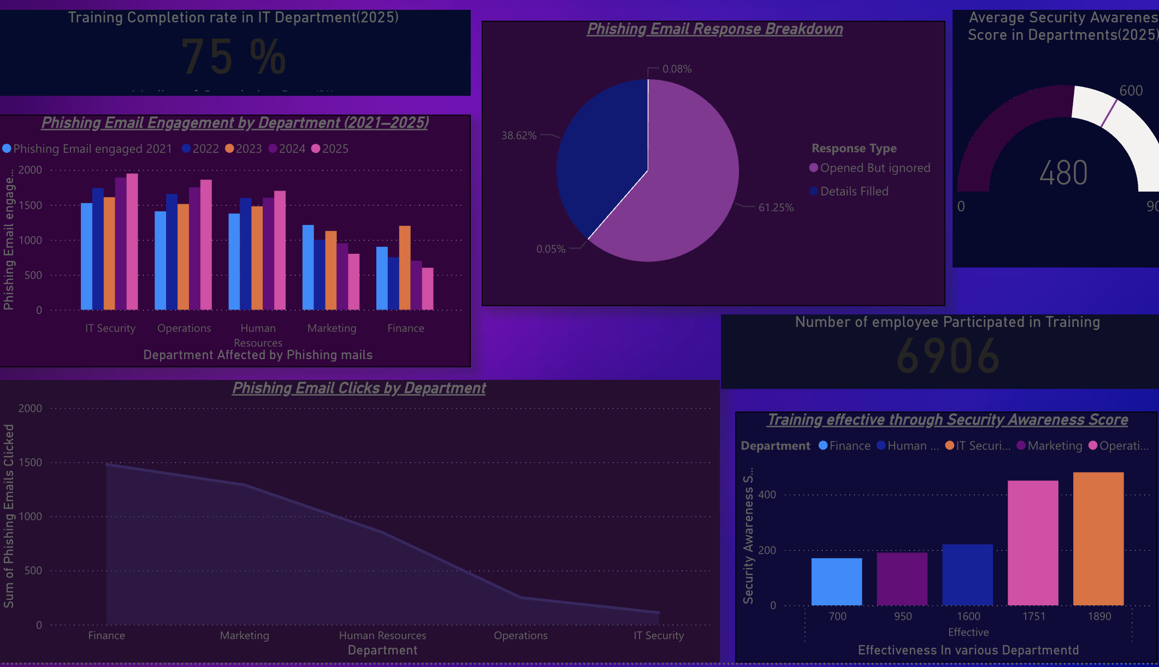

Figure 8:Power BI Dashboard for HR Manager

**SecureBank's HR Manager Analysis Dashboard** provides a detailed view of 7000 employee awareness and engagement concerning phishing simulations from 2021 to 2025. It visualizes key metrics like **Phishing Email Engagement by Department**, **Phishing Email Response Breakdown**, and **Phishing Email Clicks by Department**. These insights help HR Managers identify high-risk departments and monitor the effectiveness of training programs.

Additionally, it includes **Training Completion Rates** and **Security Awareness Scores** to assess the impact of awareness initiatives across departments. The dashboard also features a **Geographical Analysis** to pinpoint vulnerable branches, ensuring targeted interventions.

Overall, the dashboard enables HR Managers to make data-driven decisions, enhance employee cybersecurity awareness, and minimize organizational vulnerabilities.

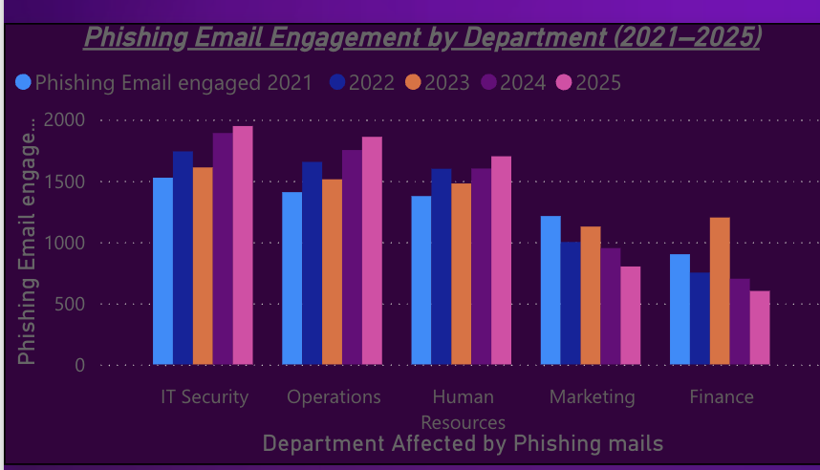

Figure 9:Phishing Email Engagement by Deaprtment

***Selection of Visualization***

Clustered Column charts Differences among categories which facilitate the identification of departments most affected over time.

***Insights***

* I**T Security** and **Operations** consistently show the highest phishing email engagements, peaking at around **1,500 emails** from 2023.
* **Marketing** and **Finance** display significantly lower engagement from 2021-2025, with numbers dropping below **800 emails** in 2025.
* This reveals where phishing attempts are most successful, helping HR focus awareness training in high-engagement departments.

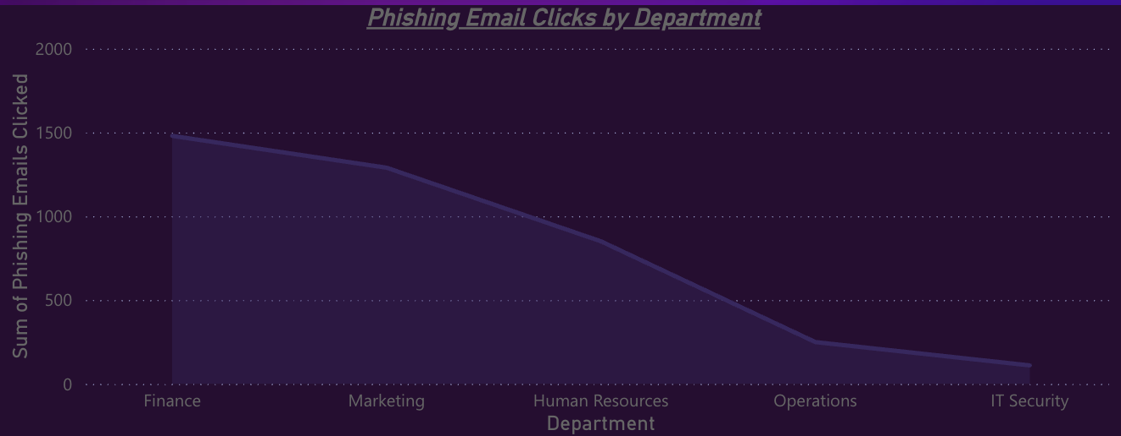

Figure 10:Phishing Email clicks by department

***Selection of Visualization***

Area charts effectively show cumulative engagement over time, emphasizing trends in click rates across departments.

***Insights***

* **Finance** recorded the highest number of phishing email clicks in 2021, with over **1,500 clicks**.
* A noticeable decline is observed year over year, especially in **IT Security**, where clicks dropped to under **500** by 2025.

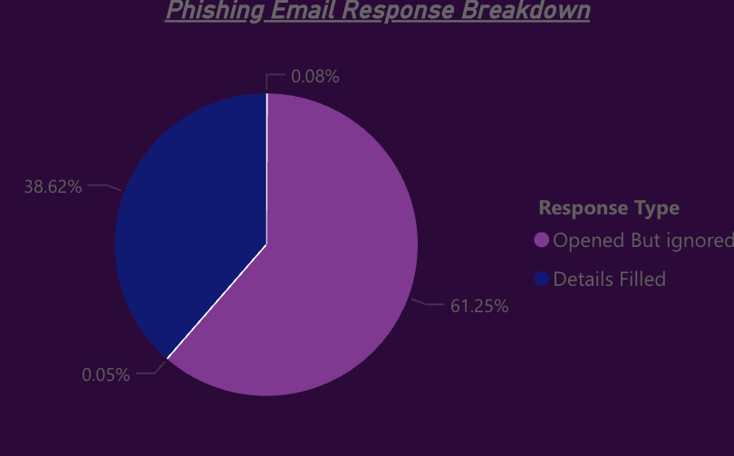

Figure 11:Most Responsive way towards Phishing Emails

***Selection of Visualization***

A pie chart is ideal for displaying proportions, making it easy to identify the distribution between "Opened But Ignored" and "Details Filled".

***Insights***

* **61.25%** of phishing emails were **Opened But Ignored**, suggesting low reporting behaviour.
* **38.62%** resulted in **Details Filled**, indicating high risk.
* The extremely low percentages of **0.08%** and **0.05%** suggest minimal interaction in other categories, which are almost negligible.
* The **Finance Department** shows high click rates, likely contributing to both ignored and filled responses, signalling weak training effectiveness.

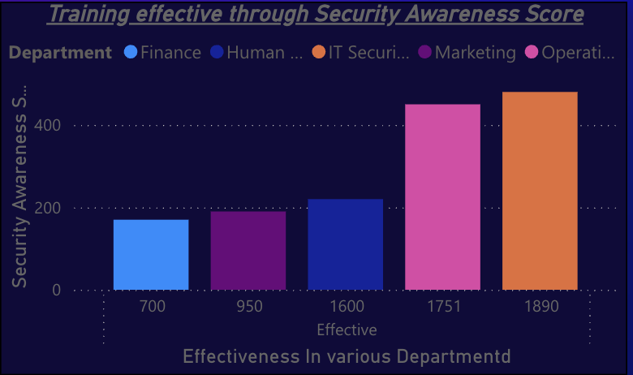

Figure 12:Training Effectiveness Through Security Awareness score

***Selection of Visualization***

Bar charts is used to give clear comparison of awareness levels across various departments.

***Insights***

* IT/Security and Operations lead in security awareness with scores of **1,890** and **1,751** respectively.
* **Finance** and **Marketing** lag behind with scores under **1,000**, indicating a gap in cybersecurity knowledge.
* These insights allow HR to target training where awareness is weakest.

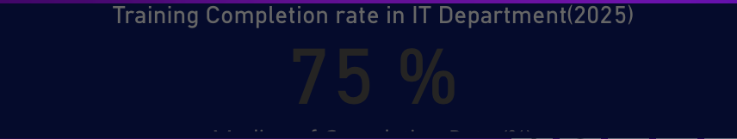

Figure 13:Training Completion rate in IT Department

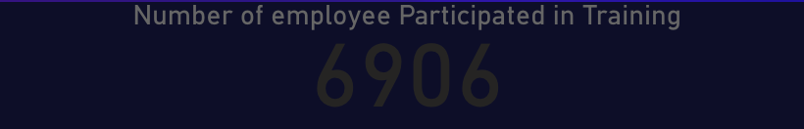

Figure 14:Number of Employee Participated

***Selection of Visualization***

KPI Cards highlight important metrics in an easily digestible form

***Insights***

* **75%** training completion rate indicates a good level of participation but also room for improvement.
* This metric is vital for understanding how prepared IT staff are against phishing threats.
* A total of **6,906 employees** participated in phishing awareness training. Among them, **1,890** in IT Security and **1,751** in Operations showed the highest effectiveness, followed by **1,600** in Marketing, **950** in Human Resources, and **700** in Finance. This reflects strong engagement in IT and Operations

***Selection of Visualization***

Gauge charts are perfect for visualizing performance against a benchmark.

***Insights***

* The **average security awareness score** for 2025 is **480** with target value as **600**, representing around 75**% awareness level**.
* This shows there is room for improvement, particularly in high-risk departments like Finance and Marketing.

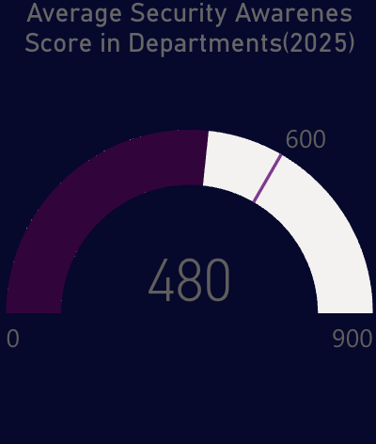

Figure 15:Average Security awareness score

**Recommendations:**

* ***Role-Based Phishing Training:***  
  Implement focused training for departments with higher click-through rates like Finance and HR to address specific vulnerabilities **(Kholoud Althobaiti, 2024).**
* ***Quarterly Phishing Simulations:***  
  Conduct regular phishing tests to track progress and identify improvement areas **(Beuran, 2025).**
* ***Immediate Feedback Mechanism:***  
  Provide instant feedback after simulations to help employees learn from mistakes, increasing awareness and reducing repeat errors **(Lee Heesuk, 2022).**
* ***Enhanced Cybersecurity Awareness Sessions:***  
  Introduce advanced awareness sessions for high-risk departments to boost vigilance against sophisticated phishing tactics **(Kalevrosoglou, 2024).**

***IT Security Team Dataset***

*Objectives*

* **Monitor Risk Levels:** Track phishing risk levels (High, Medium, Low) from 2021 to 2025 to identify vulnerabilities.
* **Track Incident Response:** Analyse action logs like Password Resets, Security Training, and Access Revoked to measure IT intervention effectiveness.
* **Evaluate Attack Mechanisms:** Identify the most successful phishing delivery methods, such as SMS Phishing and Impersonation.
* **Prevent Data Breaches:** Monitor data compromise incidents to enhance defences and prevent future breaches.

*Advantages*

* **Identify High-Risk Areas:** Easily spot high-risk levels to strengthen defences.
* **Improve Response Strategies:** Understand which actions are most effective in reducing phishing risks.
* **Target Vulnerable Mechanisms:** Focus on the attack methods that are most successful.
* **Prevent Data Leaks:** Quickly identify breaches to prevent future incidents.

*Assumptions*

* **Data Accuracy:** It is assumed that incident logs and phishing metrics are accurately recorded and updated.
* **Consistent Attack Patterns:** Attack delivery mechanisms are assumed to remain consistent for analysis.
* **Effective IT Interventions:** IT responses such as password resets and training are assumed to reduce vulnerabilities.
* **Access to Reliable Data:** IT managers have access to real-time, reliable data for effective decision-making.

|  |  |  |  |
| --- | --- | --- | --- |
| ****Attribute**** | ****Data Type**** | ****Description**** | ****Business Rule**** |
| |  |  | | --- | --- | | **Incident ID** |  |  |  | | --- | |  | | |  |  | | --- | --- | | Character |  | | Unique identifier for each phishing incident. Primary Key. | Primary Key, Must be a combination of letters and numbers. Cannot be NULL. |
| **Employee ID** | |  | | --- | | Character | | Unique identifier for each employee. | Must link to a valid Employee ID from the HR Manager dataset. Cannot be NULL. |
| **Risk Level** | Character | Indicates the level of phishing risk (High, Medium, Low). | Must be one of three categories: High, Medium, Low. Cannot be NULL. |
| **Attack Delivery Mechanism** | Character | Type of delivery mechanism (e.g., SMS Phishing, Impersonation). | Must match predefined delivery mechanism types. Cannot be NULL. |
| **Data Compromised** | Numeric | Number of data breaches caused by phishing incidents. | Must be a non-negative integer. If compromised, must link to a campaign ID. Cannot be NULL. |
| **Action Taken** | Character | Type of action performed (e.g., Password Reset, Security Training Assigned, Access Revoked). | Must match predefined actions. Cannot be NULL. |

***Phishing Risk Assessment Dashboard to enhance Cybersecurity***

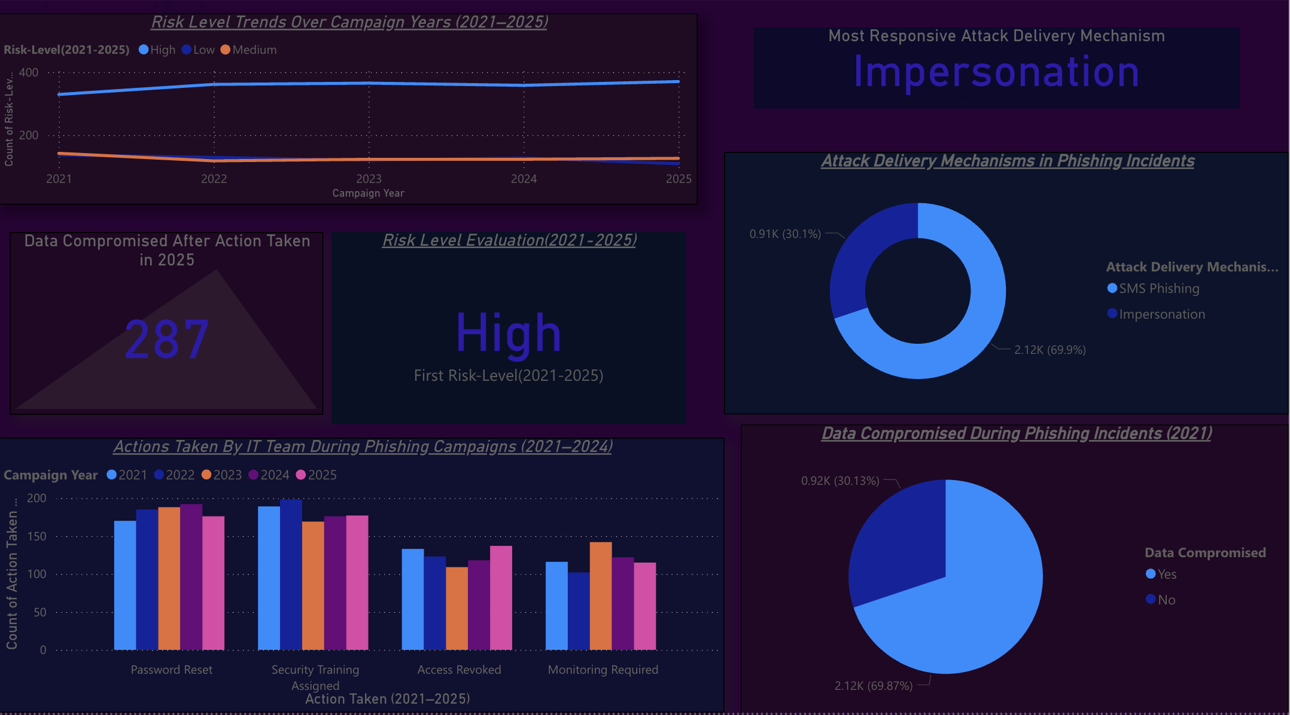

Figure 16:Power Bi Dashboard For IT/ Security Team

Phishing risks, attack methods, and IT response efforts from 2021 to 2025 are clearly illustrated on the IT Security Team Dashboard for 6000 employees. It features line charts to monitor risk levels over time, pie charts illustrating the most prevalent attack types (such as Impersonation and SMS Phishing), and bar charts indicating the frequency of IT actions like password resets and security training. This assists the IT team in easily identifying high-risk zones, comprehending which attacks are most successful, and evaluating the effectiveness of their responses. All in all, it facilitates the safeguarding of Secure Bank against online dangers.

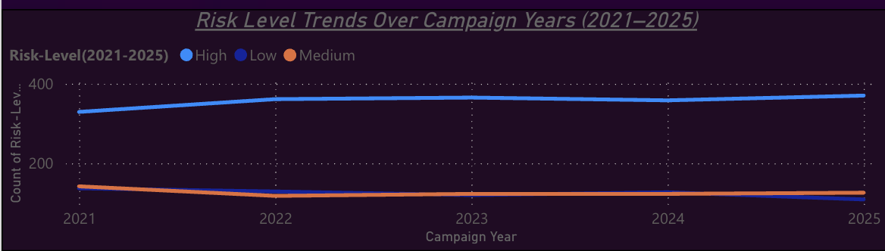

Figure 17:Risk Level Trend

***Selection of Visualization***

Line charts are ideal for visualizing trends over time, making it easy to spot changes and fluctuations

***Insights***

* High-risk levels consistently stayed above 300 incidents per year, showing persistent vulnerabilities.
* Medium and low-risk levels remained relatively stable, with low-risk incidents consistently under 100.
* The trend indicates that critical vulnerabilities are not significantly decreasing over time, signalling a need for stronger interventions.

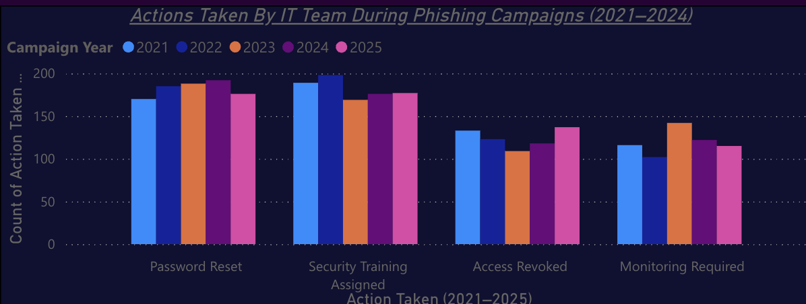

Figure 18:Action Taken

***Selection of Visualization***

Clustered column chart allow for easy comparison of IT actions taken across different years.

***Insights:***

* **Password Resets** and **Security Training Assignments** were the most common, averaging **150–170 actions annually**, with a slight decline after **2024**.
* **Access Revoked** and **Monitoring Required** remained under **150 cases** yearly, highlighting gaps in proactive security measures.

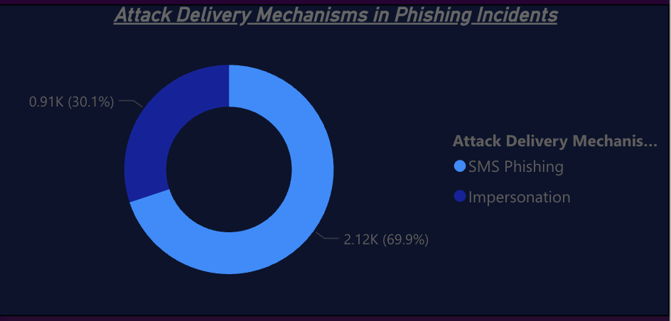

Figure 19:Attack Delivery Mechanism

***Selection of Visualization***

Donut charts effectively illustrate proportions, making it clear which mechanisms are most used.

***Insights:***

* **Impersonation (69.9%)** is the dominant attack method, followed by **SMS Phishing (30.1%) from 2021-2025**.
* This highlights the need for targeted awareness training specifically against impersonation tactics.

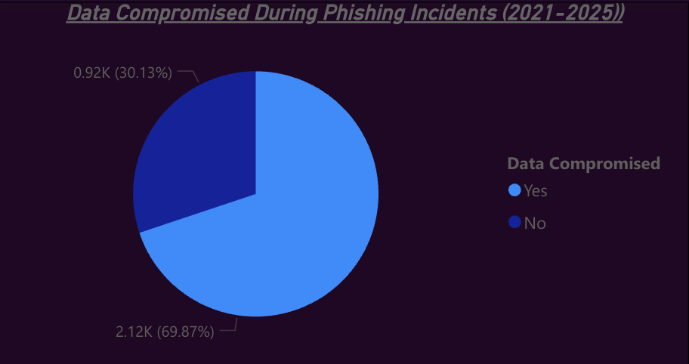

Figure 20:Data compromised

***Selection of Visualization***

Pie charts helps in understanding the proportion of data breaches over the years.

I**nsights:**

* In 2021, **69.87%** of incidents led to data compromise, while only **30.13%** did not.
* This indicates a high level of vulnerability and the need for stronger preventive actions.

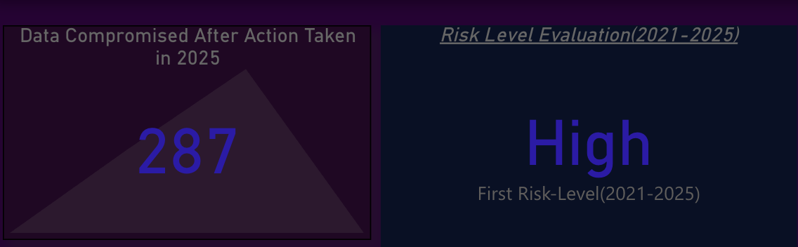

Figure 21:Data compromised and Risk level

***Selection of Visualization***

KPI cards are perfect for showcasing single metrics clearly and prominently.

***Insights:***

* In 2025, **287 data compromises** were recorded even after action was taken, indicating that current measures are not fully effective in preventing data leaks.
* The overall risk level for 2021–2025 was categorized as **High**, indicating significant exposure to phishing threats despite preventive measures.

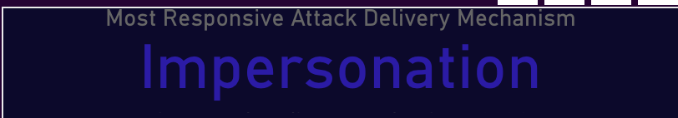

Figure 22:Most Responsive Attack delivery Mechanism

***Selection of Visualization***

Text card helps in highlighting the most impactful mechanism helps focus on priority threats.

***Insights:***

* **Impersonation** is the most effective attack mechanism, consistently outperforming other methods, suggesting that employees are more susceptible to these tactics.

***Recommendation***

* **Establish a Dedicated Incident Response Team:**  
  Creating a focused team to quickly respond to phishing incidents reduces damage and improves recovery time **(Kholoud Althobaiti, 2024).**
* **Implement Multi-Factor Authentication (MFA):**  
  Securing accounts with MFA helps prevent unauthorized access during phishing attempts, protecting sensitive data **(IEEE, 2024).**
* **Conduct Regular Phishing Simulations and Training:**  
  Training IT teams with realistic phishing scenarios enhances detection skills and minimizes risks (**Beuran, 2025; Abbas, 2024).**
* **Develop a Clear Incident Response Plan:**  
  Having structured steps for handling phishing breaches ensures business continuity and minimizes impact **(Lee Heesuk, 2022).**

***References***

Abbas, A. (2024). Evolving Phishing Défense: Innovative Défense Mechanisms and Effective Measurement Strategies. Retrieved from <https://www.researchgate.net/profile/Asad-Abbas-41/publication/384355762_Evolving_Phishing_Defense_Innovative_Defense_Mechanisms_and_Effective_Measurement_Strategies/links/66f564f0869f1104c6b5b592/Evolving-Phishing-Defense-Innovative-Defense-Mechanisms-and-Effective-Measurement-Strategies.pdf>

Althobaiti, K. (n.d.). A Case Study of Phishing Incident Response in an Educational Organization. Retrieved from <https://dl.acm.org/doi/abs/10.1145/3476079>

Beuran, R. (2025). Cybersecurity Awareness Training. In Cybersecurity Education and Training. Springer. Retrieved from <https://link.springer.com/chapter/10.1007/978-981-96-0555-2_8>

Gartner. (2023). Boosting Awareness with Interactive Phishing Simulations. Retrieved from <https://www.researchgate.net/profile/Anna-Zuriel-2/publication/379640927_Implementing_Gamification_in_Corporate_Cybersecurity_Awareness_Education_A_Literature_Review/links/6611bb063d96c22bc77978d3/Implementing-Gamification-in-Corporate-Cybersecurity-Awareness-Education-A-Literature-Review.pdf>

IEEE. (2024). Implementing Multi-Factor Authentication (MFA) for Enhanced Security. Retrieved from <https://ieeexplore.ieee.org/abstract/document/10895760>

Kalevrosoglou, C. (2024). Study and analysis of cyber security attacks in Greece. Retrieved from <https://dione.lib.unipi.gr/xmlui/handle/unipi/17351>

Lee, H. (2022). The Relationship Between the Frequency of Respective Cybersecurity Training Types and Information Security Awareness in the U. S. Technology Industry. Retrieved from <https://www.proquest.com/openview/229f2e41f38db96f9a359a709b866149/1?cbl=18750&diss=y&pq-origsite=gscholar>

**Appendices**



**Phishing Campaign Manager Dataset**





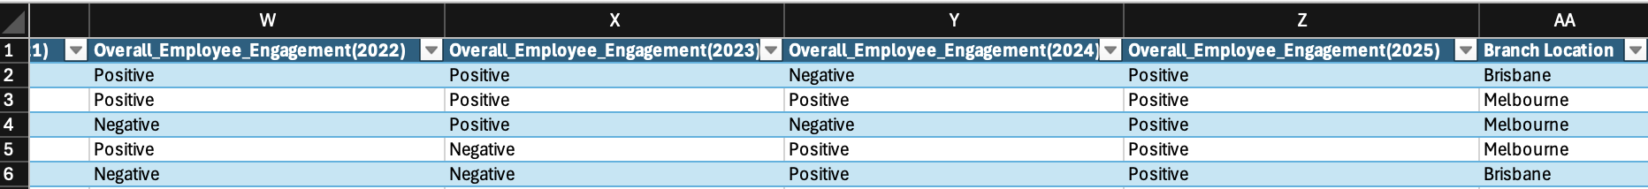

**HR Manager Dataset**



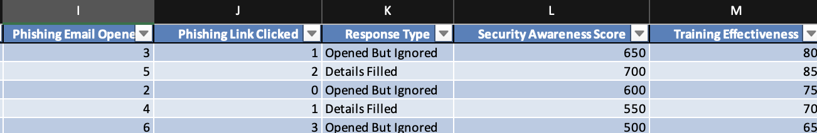

**IT/Security Team**

